Concepts Covered: Beliefs, Experience, Conflict, Conflict Resolution, Compromise, Cooperation

Essential Understandings:

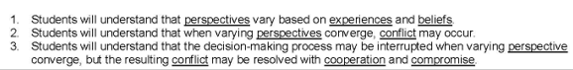

4th Grade GATE students participate in Problem Based Learning (PBL) as they try to convince the Birmingham Zoo to add a Giant Panda exhibit. Students conducted in-depth research, analyzed and synthesized information, then created the perfect Giant Panda habitat.

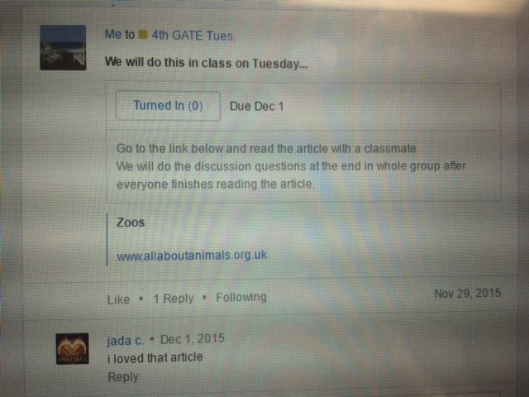

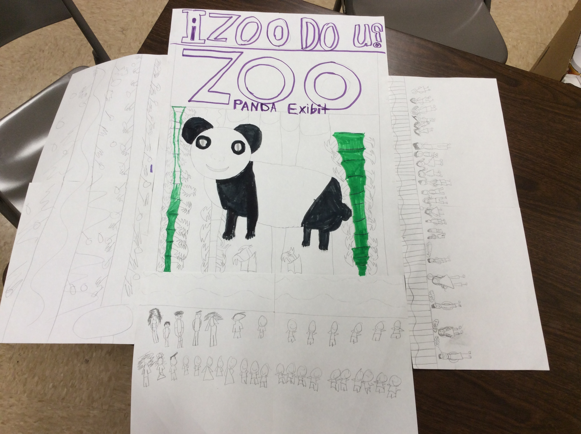

Made in Office 2007 for office2007.com

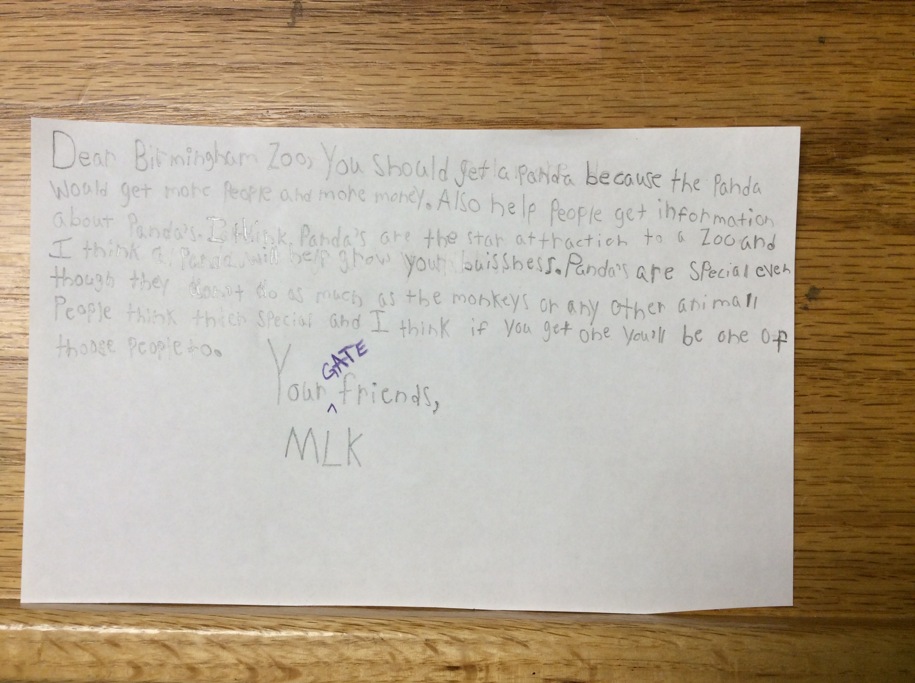

4th Grade:

iZoo, Do You? The Answer Isn’t Black and White